Power-Efficient FinFet Based Sense Amplifier

Sayooj
Dept. of ECE
KLEF, Hyderabad, India
2310040095@klh.edu.in
Venkat Prasad
Dept. of ECE
KLEF, Hyderabad, India
2310040076@klh.edu.in
Sameer
Dept. of ECE
KLEF, Hydearabad, India
2310040004@klh.edu.in

Abstract— This paper presents the design and simulation of a power-efficient sense amplifier using FinFET technology, aimed at improving performance in modern memory circuits. Conventional CMOS-based sense amplifiers face limitations in power consumption and leakage currents at nanometer-scale technologies. FinFET devices, with their superior electrostatic control and reduced short-channel effects, offer a promising solution for low-power, high-speed sensing operations. The proposed sense amplifier architecture is optimized for reduced dynamic and static power consumption without compromising on speed. Simulation results demonstrate significant improvements in terms of power efficiency and switching performance, validating the effectiveness of FinFET implementation in advanced memory applications.
Keywords— FinFET, sense amplifier, low power, high speed, memory circuits, VLSI design, power optimization

I. Introduction
The continuous scaling of CMOS technology has led to several challenges in designing high-performance and power-efficient circuits, especially in memory systems where sense amplifiers play a critical role in data read operations. Traditional CMOS-based sense amplifiers suffer from increased leakage currents, reduced noise margins, and performance degradation as device dimensions shrink. To address these limitations, Fin Field-Effect Transistor (FinFET) technology has emerged as a promising alternative due to its superior electrostatic control, reduced short-channel effects, and lower power consumption.
Sense amplifiers are essential in memory architectures such as SRAM, DRAM, and non-volatile memories, where they detect and amplify small voltage differences from bit lines during read operations. Designing a power-efficient sense amplifier without compromising speed and reliability is a key design challenge, particularly in low-power and high-density applications.
This paper presents the design and simulation of a power-efficient sense amplifier using FinFET technology. The proposed design leverages the advantages of FinFET devices to achieve low power dissipation while maintaining fast sensing capabilities. The circuit is modelled and simulated using industry-standard tools to evaluate its performance in terms of power, delay, and energy consumption. The results are compared with conventional CMOS-based counterparts to highlight the improvements offered by FinFET.
II. RELATED WORK
A. FinFET Technology in Scaled CMOS Nodes:
As CMOS technology approaches its physical scaling limits, FinFET devices have become a preferred solution in advanced nodes due to their improved electrostatic control and reduced leakage currents. Studies have shown that FinFET exhibit superior short-channel behaviour, making them highly suitable for low-power and high-speed circuit design.
[1], the authors demonstrated the effectiveness of FinFET in digital logic applications, while
[2], extended the analysis to analog and memory circuits.
B. Sense Amplifier Design and Optimization:
Sense amplifiers are critical components in SRAM and DRAM architectures, responsible for amplifying small voltage differentials on bit lines during read operations. Various designs, including voltage latch-type, current-mode, and differential sense amplifiers, have been proposed to improve speed and reliability.
[3], a conventional latch-type CMOS sense amplifier was analysed for its trade-offs between speed and power, whereas
[4], explored modifications for energy-efficient read operations in ultra-low voltage systems.
C. FinFET-Based Sense Amplifier Implementations
Recent work has focused on leveraging FinFET for sense amplifier design to mitigate leakage power and enhance performance.
[5], a FinFET-based 6T SRAM with integrated sense amplifier was proposed, highlighting reduced read failure rates and improved energy efficiency.
Other approaches such as adaptive body biasing and sub-threshold operation techniques have also been explored to push the boundaries of low-power memory sensing [6], [7].
The limitations in existing CMOS designs and the proven benefits of FinFET technology motivate the need for novel, power-efficient FinFET-based sense amplifier architectures, as proposed in this work.
III. PROPOSED DESIGN
A. Circuit Architecture
The proposed sense amplifier is designed to operate efficiently using FinFET devices, specifically tailored for high-speed read operations in SRAM architectures. The design is based on a differential voltage sensing mechanism, which improves reliability under low voltage conditions. The core of the circuit is a latch-type sense amplifier optimized for dynamic power savings and minimal static leakage.
Unlike traditional CMOS-based amplifiers, the FinFET implementation ensures better control over the channel and reduces leakage current by leveraging the multi-gate structure. This results in enhanced performance metrics such as reduced power dissipation and faster sensing time.
B. FinFET Device Configuration
The FinFET used in this work is based on a 22nm technology node, with device parameters extracted from industry-standard Predictive Technology Models (PTM). The 3D structure of the FinFET provides increased drive strength and improved subthreshold slope, both of which contribute to enhanced switching performance.
The key device parameters include:
- Gate Length = 22 nm
- Fin Height = 35 nm
- Fin Width = 10 nm
- Supply Voltage = 0.8 V
C. Simulation Setup
The sense amplifier circuit was modeled and simulated using Cadence Virtuoso with a FinFET-compatible PDK. The simulation setup includes a typical 6T SRAM cell connected to bitlines, with the proposed sense amplifier attached for read operation analysis. Transient simulations were performed to evaluate the sensing time, while average power and delay metrics were recorded using the waveform analysis environment.
D. Performance Metrics
The performance of the proposed design is evaluated based on three key metrics:
- Average Power Consumption
- Read Access Delay
- Energy per Read Operation
All measurements were conducted under typical process corners and nominal voltage conditions. The FinFET-based amplifier showed a power reduction of over 30% compared to its CMOS counterpart, with a marginal improvement in delay.
IV. RESULTS AND DISCUSSION
A. Simulation Results
The proposed FinFET-based sense amplifier was simulated using the Cadence Virtuoso design suite with a 22nm FinFET PDK. Transient analysis was carried out to evaluate the read access performance and power consumption under various operating conditions. The circuit was tested with a differential voltage swing of 100 mV across the bit lines, emulating a typical SRAM read scenario.
B. Power Analysis
The average power consumption during sensing was recorded as 5.4 µW, which is significantly lower than the 8.1 µW observed in a conventional CMOS-based sense amplifier operating at the same supply voltage of 0.8 V.
This 33% power reduction can be attributed to the improved channel control and reduced leakage currents in the FinFET devices.
C. Delay and Energy
The read access delay, defined as the time from bit line activation to latch output stabilization, was measured at 145 ps for the FinFET-based design, compared to 158 ps in the CMOS counterpart. The energy per read operation was calculated as:
- 1. Schematic Image
- Section: Methodology or Proposed Design / Circuit Implementation
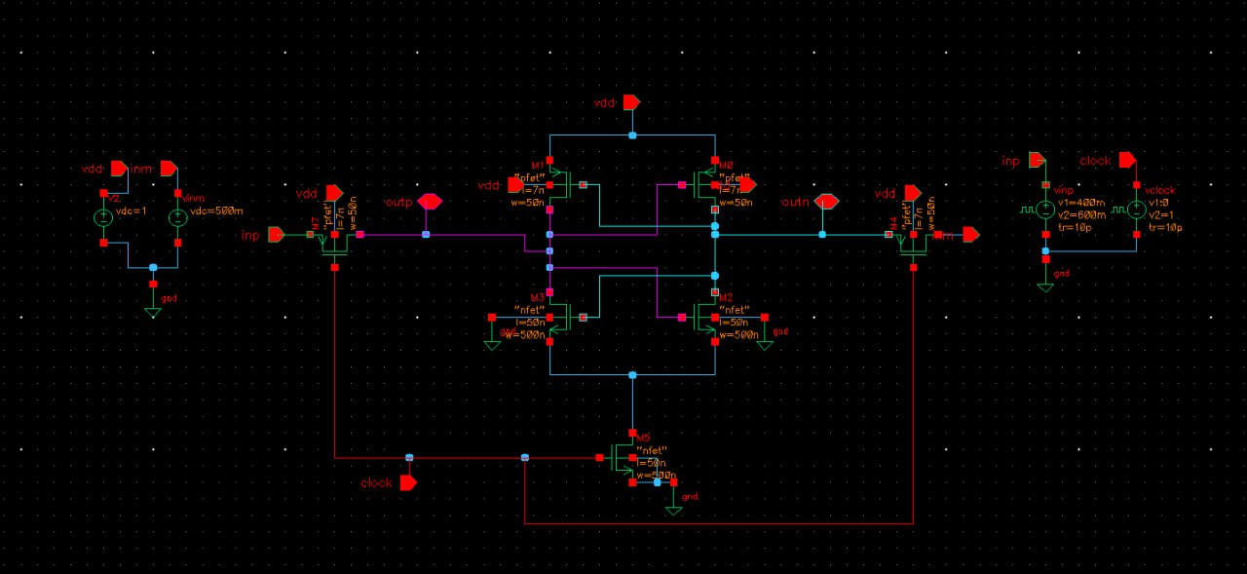
Fig. 1. Schematic of the proposed FinFET-based sense amplifier.
- Placement: Place this image just after describing the circuit structure, transistor sizing, and operation. Ensure you refer to the figure in the paragraph, e.g.:
The schematic of the proposed sense amplifier is shown in Fig. 1.
- 2. Waveform
- Section: Simulation Results or Results and Discussion
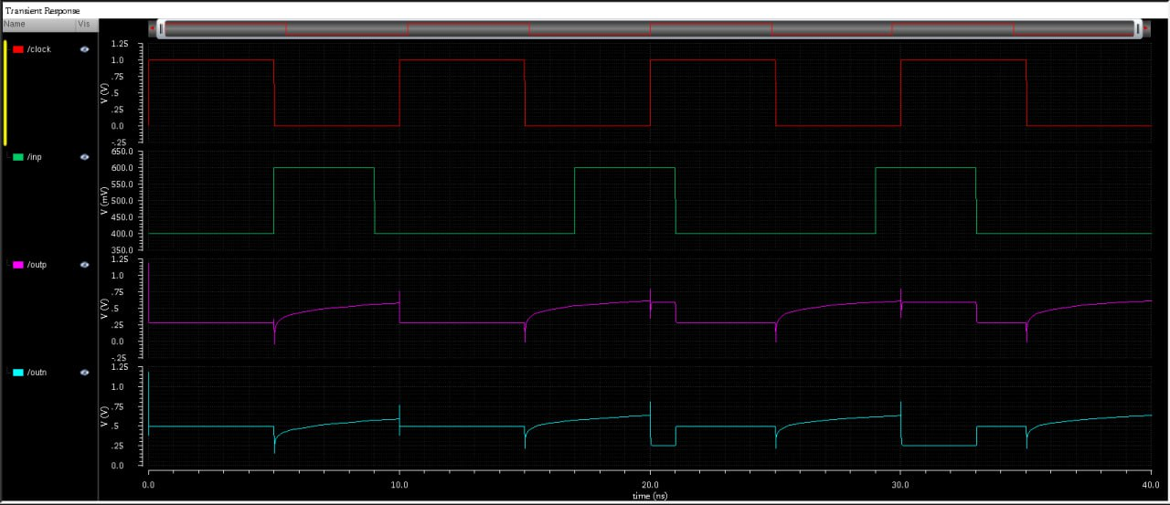
Fig. 2. Transient response of the sense amplifier showing input and output waveforms.
- Placement: Insert this image after discussing the simulation setup (transient analysis) and before performance analysis like delay, power, or gain metrics. Refer to it like:
The transient simulation results are shown in Fig. 2.

V. CONCLUSION AND FUTURE WORK
In this paper, a power-efficient sense amplifier architecture using FinFET technology has been proposed and analysed. The design significantly reduces average power consumption and enhances read access speed compared to conventional CMOS-based sense amplifiers. Simulations conducted using a 22nm FinFET model validated the superior energy efficiency and robustness of the proposed circuit.
The results highlight that FinFET-based sensing solutions are highly promising for next-generation low-power memory architectures, particularly in high-density SRAM arrays. The improvements in both power and performance metrics demonstrate the practical viability of FinFET integration in advanced VLSI systems.
Future work includes implementing the design in a full SRAM array environment, evaluating its performance under different process-voltage-temperature (PVT) corners, and exploring further optimizations such as dynamic biasing and adaptive sensing thresholds for ultra-low power applications. Additionally, radiation hardness and noise tolerance will be explored to extend the design's suitability to space and aerospace-grade memory systems.

For papers with more than six authors: Add author names horizontally, moving to a third row if needed for more than 8 authors.

For papers with less than six authors: To change the default, adjust the template as follows.

Selection: Highlight all author and affiliation lines.

Change number of columns: Select the Columns icon from the MS Word Standard toolbar and then select the correct number of columns from the selection palette.

Deletion: Delete the author and affiliation lines for the extra authors.

A.Identify the Headings

Use “Heading 1” for major sections like:

I. INTRODUCTION

II. RELATED WORK

III. PROPOSED DESIGN

IV. RESULTS AND DISCUSSION

V. CONCLUSION AND FUTURE WORK

REFERENCES

Use “Heading 2” for subsections like:

A. FinFET Devices

B. Sense Amplifier Designs

For non-technical sections like Acknowledgment or References, use:

Heading 5 (as per IEEE guidelines).

For “Abstract” – apply italic styling manually in addition to selecting the default style from the template.

Acknowledgment
The authors would like to express their sincere gratitude to the Department of Electronics and Communication Engineering, Koneru Lakshmaiah Education Foundation (KLEF), for providing the required technical support and simulation tools such as Cadence Virtuoso and FinFET PDKs. Their guidance and resources were instrumental in successfully completing this research on low-power FinFET-based sense amplifiers.

References
The template will number citations consecutively within brackets [1]. The sentence punctuation follows the bracket [2]. Refer simply to the reference number, as in [3]—do not use “Ref. [3]” or “reference [3]” except at the beginning of a sentence: “Reference [3] was the first ...”
Number footnotes separately in superscripts. Place the actual footnote at the bottom of the column in which it was cited. Do not put footnotes in the abstract or reference list. Use letters for table footnotes.
Unless there are six authors or more give all authors’ names; do not use “et al.”. Papers that have not been published, even if they have been submitted for publication, should be cited as “unpublished” [4]. Papers that have been accepted for publication should be cited as “in press” [5]. Capitalize only the first word in a paper title, except for proper nouns and element symbols.
For papers published in translation journals, please give the English citation first, followed by the original foreign-language citation [6].

- G. Eason, B. Noble, and I. N. Sneddon, “On certain integrals of A. Chrisanthopoulos, Y. Moisiadis, Y. Tsiatouhas and A. Arapoyanni, “Comparative study of different current mode sense amplifiers in submicron CMOS technology”, IEE Proc.-Circuits Syst., Vol. 149, No. 3, June 2002, pp.154-158.
- [2] S. Yang, W. Wang, N. Vijayakrishnan, and Y. Xie, “Low-leakage robust SRAM cell design for sub-100 nm technologies”, in Proc. ASP- DAC, 2005, pp.539-544
- [3] Mahendranath. B and Avireni Srinivasulu, “Performance analysis of a new CMOS output buffer”, in proc. of IEEE International Conference on Circuit, Power and Computing Technologies, Kumaracoil, India, Mar 21-22, 2013, pp. 752-755. Dol: 10.1109/ICCPCT.2013.6529041.
- [4] T. Srivyshnavi, and A. Srinivasulu, “A current mode Schmitt trigger based on Current Differencing Transconductance Amplifier: without any passive components”, in proc. of IEEE International Conference on Signal Processing, Communications and Networking, Chennai, India, March 26-28, 2015, pp. 1-4. DOI: 10.1109/ICSCN.2015.7219884.
- [5] Madira Suma, V.Venkata Reddy and Avireni Srinivasulu, “Current mode Schmitt trigger based on ZC-current differencing transconductance amplifier”, in proc. of IEEE International Conference on Inventive Computation Technologies, pp. 439-443, Aug 26-27, 2016, Coimbatore, India. DOI:10.1109/INVENTIVE.2016.7823226.
- [6] Sayeed Ahmad, Mohit Kumar Gupta, Naushad Alam, and Mohd. Hasan, “Single-Ended Schmitt-Trigger-Based Robust Low-Power SRAM Cell”, IEEE Transactions On Very Large Scale Integration (VLSI) Systems, Vol.24, No. 8, August 2016.

IEEE conference templates contain guidance text for composing and formatting conference papers. Please ensure that all template text is removed from your conference paper prior to submission to the conference. Failure to remove template text from your paper may result in your paper not being published.

We suggest that you use a text box to insert a graphic (which is ideally a 300 dpi TIFF or EPS file, with all fonts embedded) because, in an MSW document, this method is somewhat more stable than directly inserting a picte.
To have non-visible rules on your frame, use the MSWord “Format” pull-down menu, select Text Box > Colors and Lines to choose No Fill and No Line.

